Thank you for attending this experiment. This experiment consist of two sessions on separate days. If this is your first session, experimenter will arrange the time and date for the next session after you finished the session today. Each session is separated into two halves.

The procedure of the first half of the session is illustrated as follow:

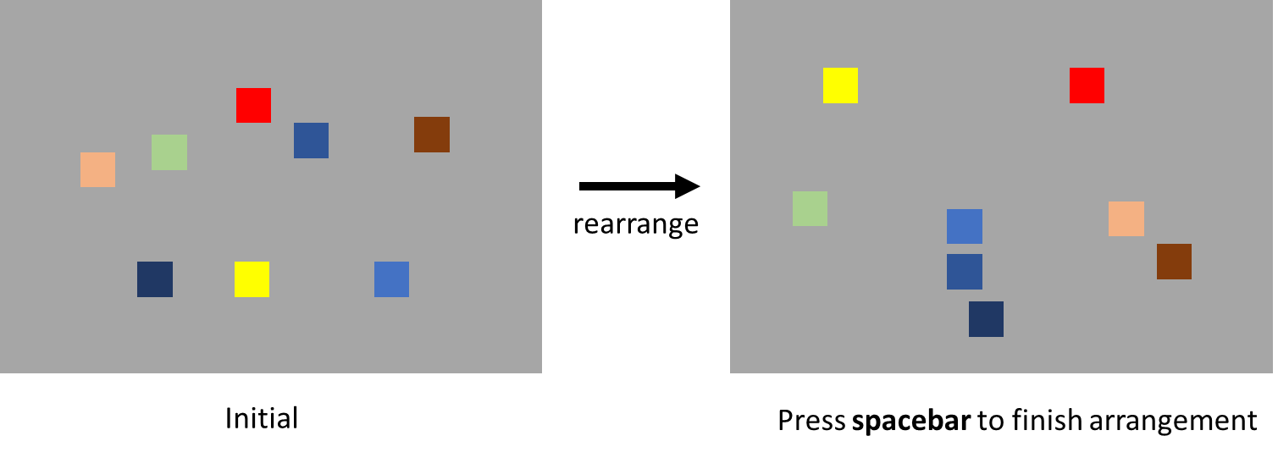

At the beginning of the each trial, you will see several stimuli. Your task is rearrange the stimuli according to the similarity between the stimuli. The distance between two stimuli indicates the similarity between the stimuli. You can rearrange the stimuli by **drag-and-drop with left-mouse button**. If **two stimuli are similar** to each other, you should rearrange both stimuli **close together**. If **two stimuli are dissimilar**, then you should rearrange both stimuli **far apart**. There is no correct answer in this half of the experiment, but please try your best to rearrange most, if not all, the stimuli according to this rule. After you finished arranging the stimuli, please press space bar to proceed to the next trial. There is no time limit in this half of the experiment.

Before the actual testing trials begin, there will be two practice trials. Please use the practice trials to familiar with the procedure and the response method of this half of the session. If you have any question, please inform the experimenter.

Once the first half of the experiment is finished, please inform the experimenter in order to proceed the second half of the experiment.

The procedure of the second half of the experiment is illustrated as follow:

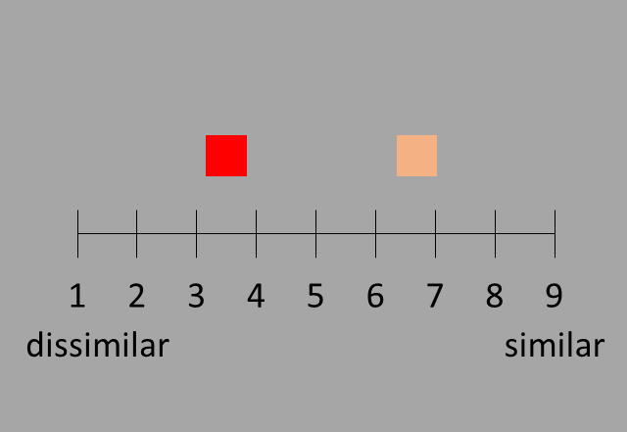

In each trial, you will see a pair of stimuli. Please rate the similarity between the stimuli by clicking on the scale. **Smaller** rating indicates two stimuli are more **dissimilar** to each other. **Larger** rating indicates two stimuli are more **similar** to each other. There is no time limit in this half of the experiment.

Before the actual testing trials begin, there will be four practice trials. Please use the practice trials to familiar with the procedure and the response method of this half of the session. If you have any question, please inform the experimenter.

Once the second half of the experiment is finished, please inform the experimenter.